COS40007 Artificial Intelligence Engineering
Portfolio Assessment 1
Exploratory Data Analysis (EDA) & Data Preparation
Dataset: Appliances Energy Prediction (UCI Machine Learning Repository)
Student name: Dinh Phu Nguyen
Student ID: 105027282
Lecturer: Dr. Duc Tho Mai
Unit: COS40007 Artificial Intelligence Engineering
Task: Portfolio Assessment 1
Submission date: 04/10/2026
GitHub repository: https://github.com/phu1009/COS40007---AI-Engineering-

Generative AI Use Declaration
"I used Claude (Anthropic) to assist with suggesting a suitable dataset, structuring and debugging my Python environment. All final code, interpretations, and conclusions are my own work after verification."
Evidence of the GenAI use is provided in Appendix A.

Exploratory Data Analysis Report
Student Name: Dinh Phu Nguyen
Class Number: 105027282
Date: 04/10/2026
Dataset: Appliances Energy Prediction – Candanedo, L. (2017), UCI Machine Learning Repository, https://doi.org/10.24432/C5VC8G

1. Dataset Overview
- Brief description of the dataset and its engineering relevance.
The dataset records the electricity used by household appliances in a low-energy (passive-house standard) house in Stambruges, Belgium, every 10 minutes for about 4.5 months (11 January – 27 May 2016). Indoor temperature and humidity in nine locations come from a wireless ZigBee sensor network, and outdoor weather comes from the Chièvres airport weather station about 12 km away (Candanedo et al., 2017).
Engineering relevance (AI engineering): this is a typical AIoT forecasting problem. Data from a low-cost sensor network is used to predict household energy demand, which is the basis of building energy management systems, demand response and peak shaving. It also contains the practical challenges of real ML pipelines: time-series data, a strongly skewed target, collinear sensors, a faulty sensor and two deliberately random noise variables.
- Number of rows: 19,735 (one reading every 10 minutes; all 19,735 expected timestamps are present).
- Number of columns: 29 in the raw file (1 timestamp, 28 numeric); 26 after cleaning (Section 2).
- Target variable: Appliances – energy used by appliances in each 10-minute interval (Wh, int64). It covers plug loads only: heating, the hot-water heat pump, ventilation and lighting are metered separately.
- Problem type (regression/classification): Regression in its original form (continuous numeric target), converted into a 3-class classification problem as required by the brief.
- If regression: explain whether class conversion was performed (if applicable).
Yes. The target is strongly right-skewed (skewness 3.39; mean 97.7 Wh vs median 60 Wh; maximum 1,080 Wh) and is recorded in 10 Wh steps, so 22% of readings are exactly 50 Wh (Figure 1). Equal-width and equal-frequency binning were compared for 3, 4 and 5 classes (Table 1), using the balance ratio (smallest ÷ largest class).
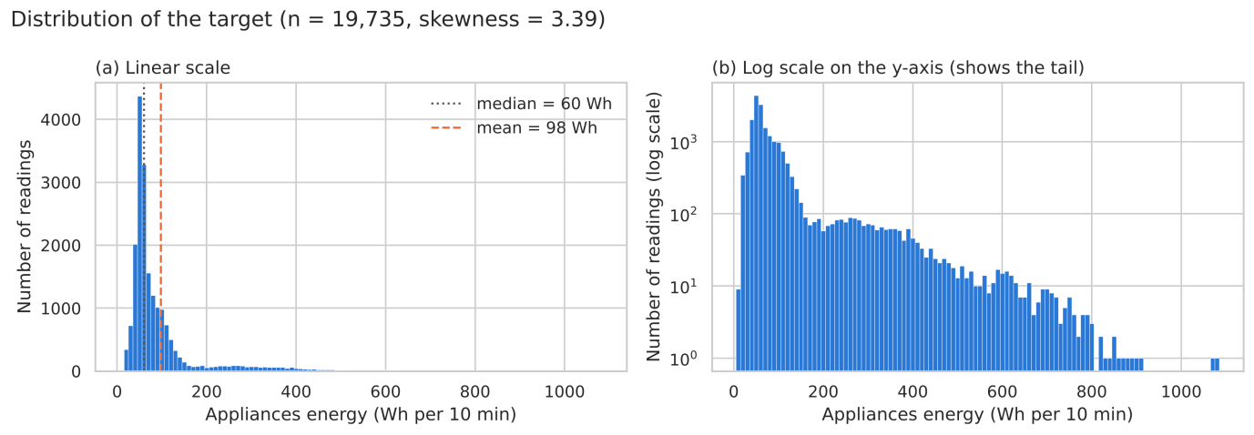
Figure 1: Distribution of the target Appliances on a linear scale (a) and with a log y-axis (b), which shows the long right tail.
Table 1: Comparison of binning methods for the target.
Method | k | Class boundaries (Wh) | Class shares (%) | Largest class (%) | Balance ratio
Equal-width | 3 | 9, 367, 723, 1080 | 96.2 / 3.6 / 0.2 | 96.2 | 0.002
Equal-frequency | 3 | 10, 50, 80, 1080 | 37.8 / 30.6 / 31.5 | 37.8 | 0.810
Equal-width | 4 | 9, 278, 545, 812, 1080 | 93.1 / 5.7 / 1.1 / 0.1 | 93.1 | 0.001
Equal-frequency | 4 | 10, 50, 60, 100, 1080 | 37.8 / 16.6 / 24.1 / 21.4 | 37.8 | 0.440
Equal-width | 5 | 9, 224, 438, 652, 866, 1080 | 91.0 / 6.7 / 1.7 / 0.5 / 0.0 | 91.0 | 0.000
Equal-frequency | 5 | 10, 50, 60, 70, 110, 1080 | 37.8 / 16.6 / 7.9 / 19.9 / 17.7 | 37.8 | 0.209

Equal-width binning fails because the long tail stretches the range (96.2% of readings in one class, far above the 80% imbalance level in the brief). With 4 or 5 equal-frequency classes the very common values 50 and 60 Wh cannot be split, leaving classes of 16.6% and 7.9%. I therefore chose 3 equal-frequency classes:
  - Low (≤ 50 Wh, ≤ 300 W average power): 37.8% of readings – base load; the median between 00:00 and 06:00 is exactly 50 Wh.
  - Medium (60–80 Wh, 360–480 W): 30.6% – light daytime activity (hourly median 70–80 Wh between 09:00 and 16:00).
  - High (≥ 90 Wh, ≥ 540 W): 31.5% – active use of high-power appliances, including the 17:00–20:00 cooking peak.
The boundaries come from the data (quantiles) but also match the daily consumption cycle (Figure 2). The classes cannot be exactly equal because readings with the same value must stay in the same class; with a balance ratio of 0.81 they are reasonably balanced (Figure 3). The numeric target is kept for the correlation analysis.
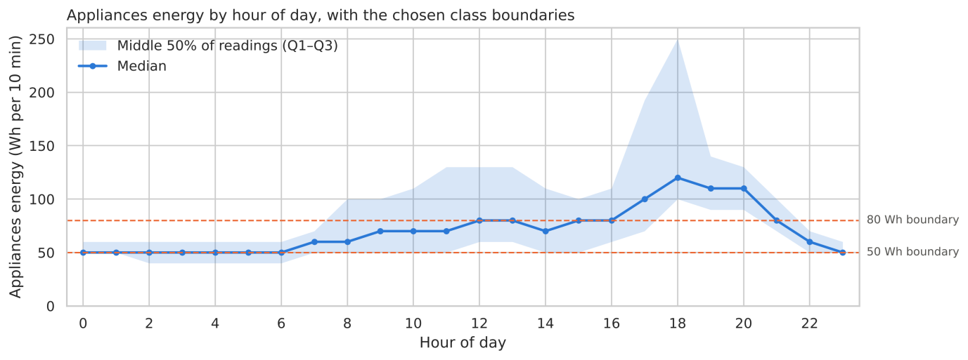
Figure 2: Appliance energy by hour of day (median and interquartile range) with the chosen class boundaries.
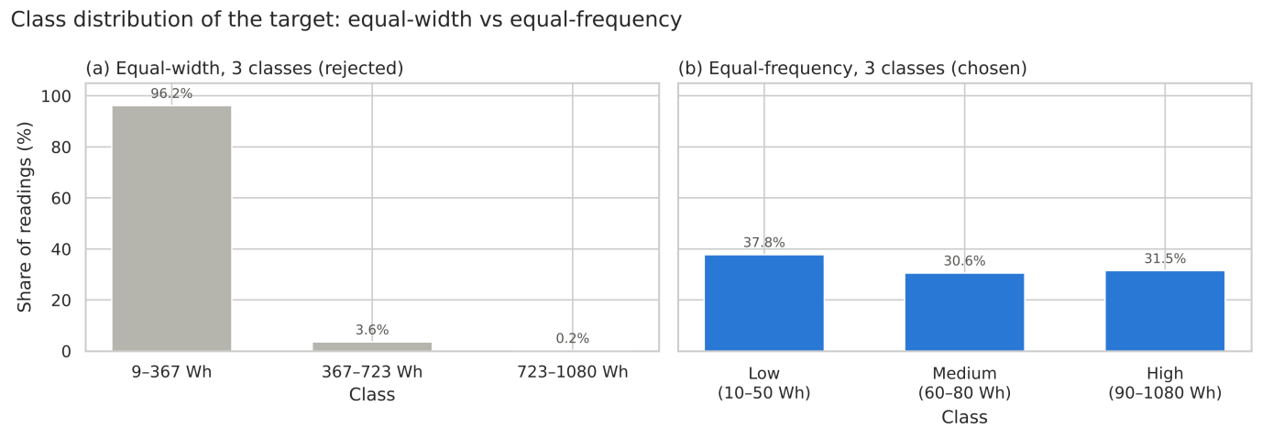
Figure 3: Class distribution with equal-width binning (rejected) and equal-frequency binning (chosen).
- Summary statistics of numerical variables (mean, std, min, max).
Table 2 lists the mean, standard deviation, minimum and maximum of every column in the raw data, with its data type and unit. Indoor temperatures lie between about 15 and 30 °C and indoor humidity between 20 and 63% (96% in the bathroom), while outdoor temperature ranges from −5 to 26 °C. lights is 0 Wh in 77% of readings.

Required Evidence:
- Dataset shape (df.shape): (19735, 29) – 19,735 rows × 29 columns.
- Data types (df.dtypes): 26 float64 sensor columns, 2 int64 columns (Appliances, lights) and 1 text column (date) – see Table 2.
- Summary statistics (df.describe()): see Table 2.
Table 2: Raw dataset – data types (df.dtypes) and summary statistics (df.describe()).
Column | Description | Unit | dtype | Mean | Std | Min | Max
date | Timestamp of the 10-minute reading | – | str | – | – | 2016-01-11 | 2016-05-27
Appliances | Appliance energy use (TARGET) | Wh | int64 | 97.69 | 102.52 | 10.00 | 1080.00
lights | Light fixture energy use | Wh | int64 | 3.80 | 7.94 | 0.00 | 70.00
T1 | Temperature – kitchen | °C | float64 | 21.69 | 1.61 | 16.79 | 26.26
RH_1 | Relative humidity – kitchen | % | float64 | 40.26 | 3.98 | 27.02 | 63.36
T2 | Temperature – living room | °C | float64 | 20.34 | 2.19 | 16.10 | 29.86
RH_2 | Relative humidity – living room | % | float64 | 40.42 | 4.07 | 20.46 | 56.03
T3 | Temperature – laundry room | °C | float64 | 22.27 | 2.01 | 17.20 | 29.24
RH_3 | Relative humidity – laundry room | % | float64 | 39.24 | 3.25 | 28.77 | 50.16
T4 | Temperature – office | °C | float64 | 20.86 | 2.04 | 15.10 | 26.20
RH_4 | Relative humidity – office | % | float64 | 39.03 | 4.34 | 27.66 | 51.09
T5 | Temperature – bathroom | °C | float64 | 19.59 | 1.84 | 15.33 | 25.80
RH_5 | Relative humidity – bathroom | % | float64 | 50.95 | 9.02 | 29.82 | 96.32
T6 | Temperature – outside, north wall | °C | float64 | 7.91 | 6.09 | -6.07 | 28.29
RH_6 | Relative humidity – outside, north wall | % | float64 | 54.61 | 31.15 | 1.00 | 99.90
T7 | Temperature – ironing room | °C | float64 | 20.27 | 2.11 | 15.39 | 26.00
RH_7 | Relative humidity – ironing room | % | float64 | 35.39 | 5.11 | 23.20 | 51.40
T8 | Temperature – teenager room 2 | °C | float64 | 22.03 | 1.96 | 16.31 | 27.23
RH_8 | Relative humidity – teenager room 2 | % | float64 | 42.94 | 5.22 | 29.60 | 58.78
T9 | Temperature – parents room | °C | float64 | 19.49 | 2.01 | 14.89 | 24.50
RH_9 | Relative humidity – parents room | % | float64 | 41.55 | 4.15 | 29.17 | 53.33
T_out | Outdoor temperature (weather station) | °C | float64 | 7.41 | 5.32 | -5.00 | 26.10
Press_mm_hg | Atmospheric pressure (station) | mm Hg | float64 | 755.52 | 7.40 | 729.30 | 772.30
RH_out | Outdoor relative humidity (station) | % | float64 | 79.75 | 14.90 | 24.00 | 100.00
Windspeed | Wind speed (station) | m/s | float64 | 4.04 | 2.45 | 0.00 | 14.00
Visibility | Visibility (station) | km | float64 | 38.33 | 11.79 | 1.00 | 66.00
Tdewpoint | Dew point temperature (station) | °C | float64 | 3.76 | 4.19 | -6.60 | 15.50
rv1 | Random variable 1 (added by authors) | – | float64 | 24.99 | 14.50 | 0.01 | 50.00
rv2 | Random variable 2 (added by authors) | – | float64 | 24.99 | 14.50 | 0.01 | 50.00

2. Data Quality Assessment
- Missing values: 0% in all 29 columns (0 of 572,315 cells). The 10-minute time index is also complete (19,735 of 19,735 expected timestamps), so no imputation was needed. The missing-value table and heatmap are in the notebook (Section 2.1–2.2).
- Duplicates found and handled: 0 duplicated rows, 0 duplicated timestamps and 0 identical readings when the timestamp is ignored. One duplicated column pair: rv1 and rv2 are identical in every row. They are random variables added on purpose by the dataset authors, have no physical meaning and correlate r = −0.011 with the target, so both were removed.
- Outliers detected and handled: three checks were used – boxplots (Figure 4), the IQR rule (Table 3) and physical checks (valid ranges, readings stuck at sensor limits, comparison of sensors that measure the same quantity).
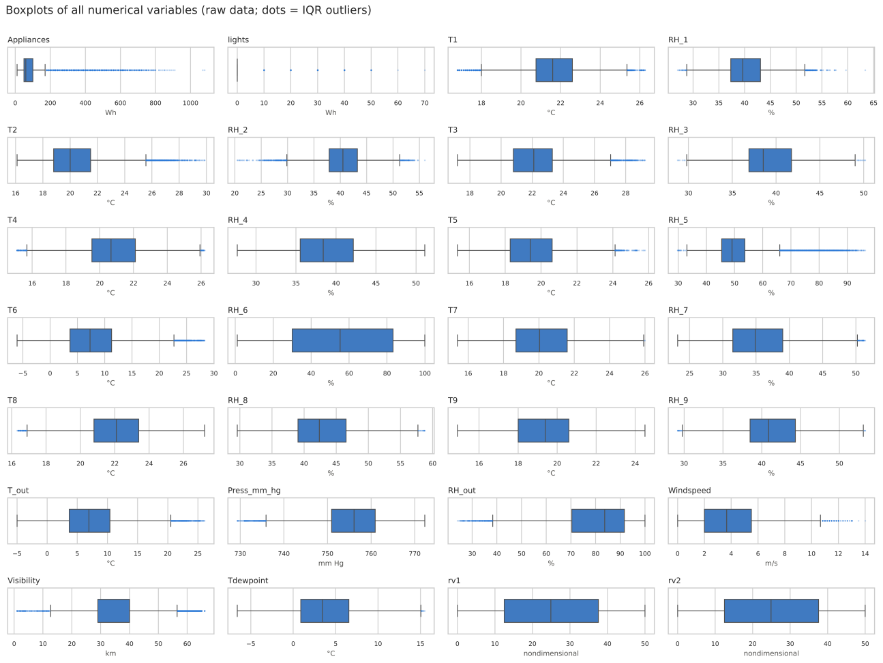
Figure 4: Boxplots of all numerical variables in the raw data (dots = IQR outliers).
Table 3: Outliers detected and how they were handled.
Variable | IQR outliers | Explanation | Decision
lights | 22.7% | 77% of readings are 0, so Q1 = Q3 = 0 and every 'lights on' reading is flagged | Keep (real behaviour)
Visibility | 12.8% | 36.6% of readings are exactly 40 km (station default/rounding) – squeezes the IQR | Keep
Appliances | 10.8% | > 175 Wh ≈ 1 kW; max 1,080 Wh ≈ 6.5 kW is realistic for oven + kettle + washing machine | Keep (peaks matter most)
RH_5 | 6.7% | Bathroom humidity up to 96% during showers (mostly 19:00–23:00) | Keep
Others | < 3% each | All values inside physically valid ranges | Keep
RH_6 | 0% | Sensor drift and clipping at 1% / 99.9% – missed by IQR, found by physical checks (Figure 5) | Drop column

Sensor fault in RH_6. RH_6 (outdoor humidity on the north wall) and RH_out (weather station) measure the same quantity. They agreed in January (monthly means 92% vs 87%), but RH_6 then drifted down to 21% in May while RH_out stayed above 70% (Figure 5). RH_6 also sits exactly at its limits: 751 readings at 99.9% (mostly January) and 1,452 at 1.0% (from 9 April, only between 08:00 and 22:00, while the station reported 24–81%). During the 1% readings the wall sensor was 2.4 °C warmer than the outdoor air (0.35 °C otherwise), which suggests it was being heated, but this alone cannot explain 1% humidity, so a gradual sensor fault is the most likely cause. Because the drift affects every reading from March, interpolating the clipped values would not fix it; RH_6 was dropped and RH_out provides the same information.
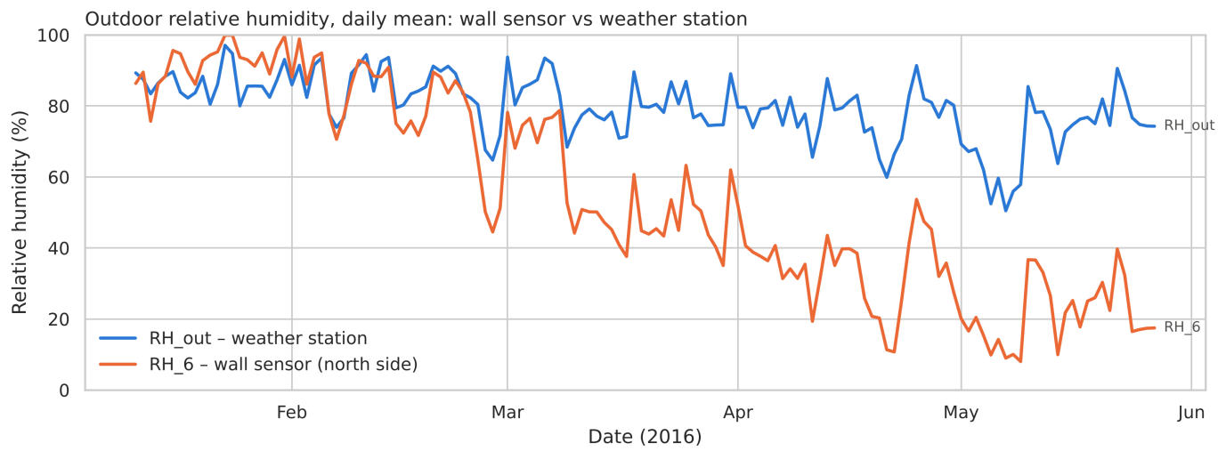
Figure 5: Daily mean outdoor humidity – wall sensor RH_6 vs weather station RH_out.
- Data types after cleaning: date converted from text to datetime64; Appliances and lights int64; the other 23 sensor columns float64. After removing rv1, rv2 and RH_6 (no rows removed), the cleaned dataset has 19,735 rows × 26 columns.

3. Key Findings from Univariate Analysis
All 24 predictors were plotted (histogram + KDE) and summarised with skewness, kurtosis, the share of zeros and a bimodality coefficient (notebook Section 4). 16 of 24 predictors are approximately symmetric (|skew| < 0.5): most indoor temperatures and humidities, Tdewpoint, Press_mm_hg and Visibility. T2, T5, T6, T_out and Windspeed are moderately right-skewed, RH_5 is highly right-skewed with a heavy tail (skew 1.87), RH_out is left-skewed (−0.92) and lights is zero-inflated (77% zeros).
- Several peaks in indoor temperatures (T9, T3, T5, T7) despite low skewness. They are seasonal: the house warms from January to May (monthly mean T9: 16.7 → 22.4 °C), and 99% of T9 readings above 21.5 °C are from May. The data is therefore not stationary over time.
- Physical reasons for skewed shapes: all 539 high T2 values occur in May (warm afternoons); bathroom humidity peaks with evening showers; outdoor air is humid at night (median 90%) and drier in the afternoon (67%), and cannot exceed 100%, which gives RH_out its left skew; wind speed cannot be negative.
- Artefacts of the weather data: Windspeed has a comb pattern because hourly whole-number readings were linearly interpolated to 10-minute steps, and Visibility has a spike at 40 km (36.6% of readings).
Figure 6 shows one predictor for each distribution type, and Figure 7 compares the skewness of all predictors. The different shapes and scales mean that scale-sensitive models will need standardisation, and RH_5 and lights may benefit from a transformation (Section 5).
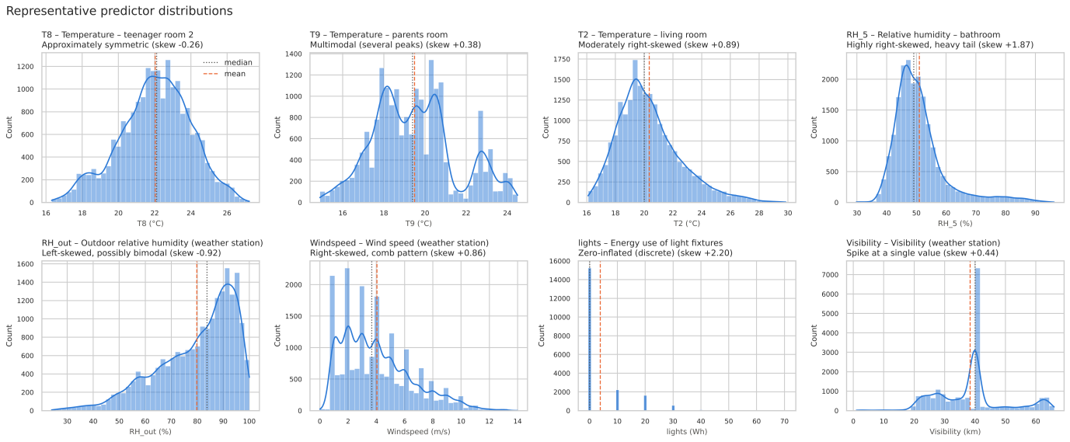
Figure 6: Representative predictor distributions (histogram + KDE; dotted = median, dashed = mean).
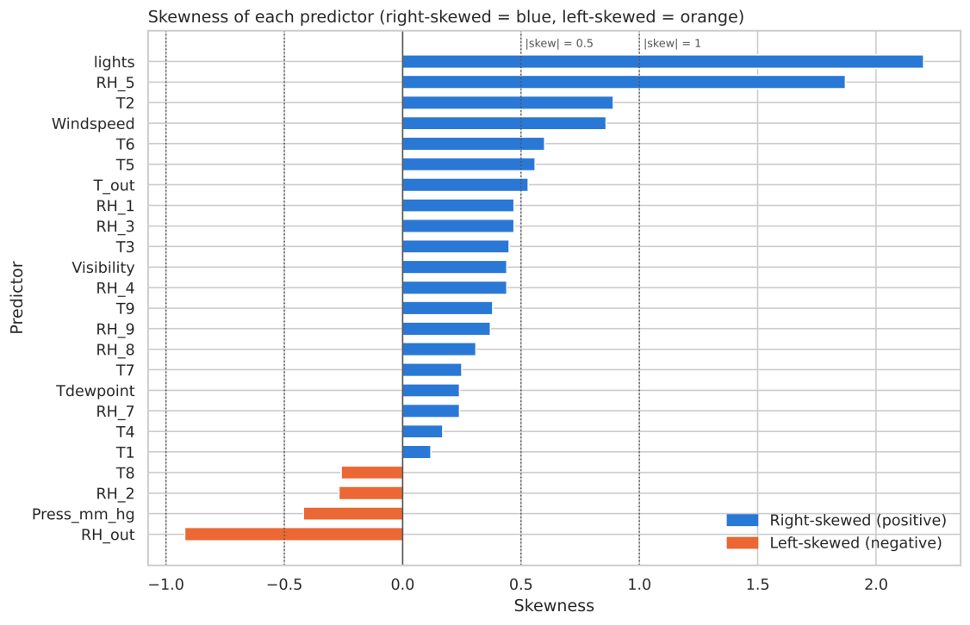
Figure 7: Skewness of each predictor, with the ±0.5 and ±1 thresholds.

4. Key Findings from Multivariate Analysis
- Top 3 features correlated with the target:
- lights (lighting energy) – Pearson r = +0.197 (Spearman ρ = +0.302)
- RH_out (outdoor humidity) – Pearson r = −0.152 (Spearman ρ = −0.269)
- T2 (living room temperature) – Pearson r = +0.120 (Spearman ρ = +0.305)
Spearman ranks the same three features first, but all correlations are weak – the best sensor explains about 4% of the target's variance (Figure 8). Spearman is larger than Pearson for most temperatures (e.g. T1: 0.244 vs 0.055) because the relationships are monotonic but not linear, and Pearson is dominated by the skewed target. Hour of day is the strongest driver: its correlation ratio η = 0.387 is about twice the best sensor, while day of week (0.086) and month (0.022) matter little. After removing each hour's mean, the correlation of RH_out falls to 0.029 and that of T2 to 0.022, so they mainly mirror the time of day; lights keeps 0.144, so it carries real occupancy information.
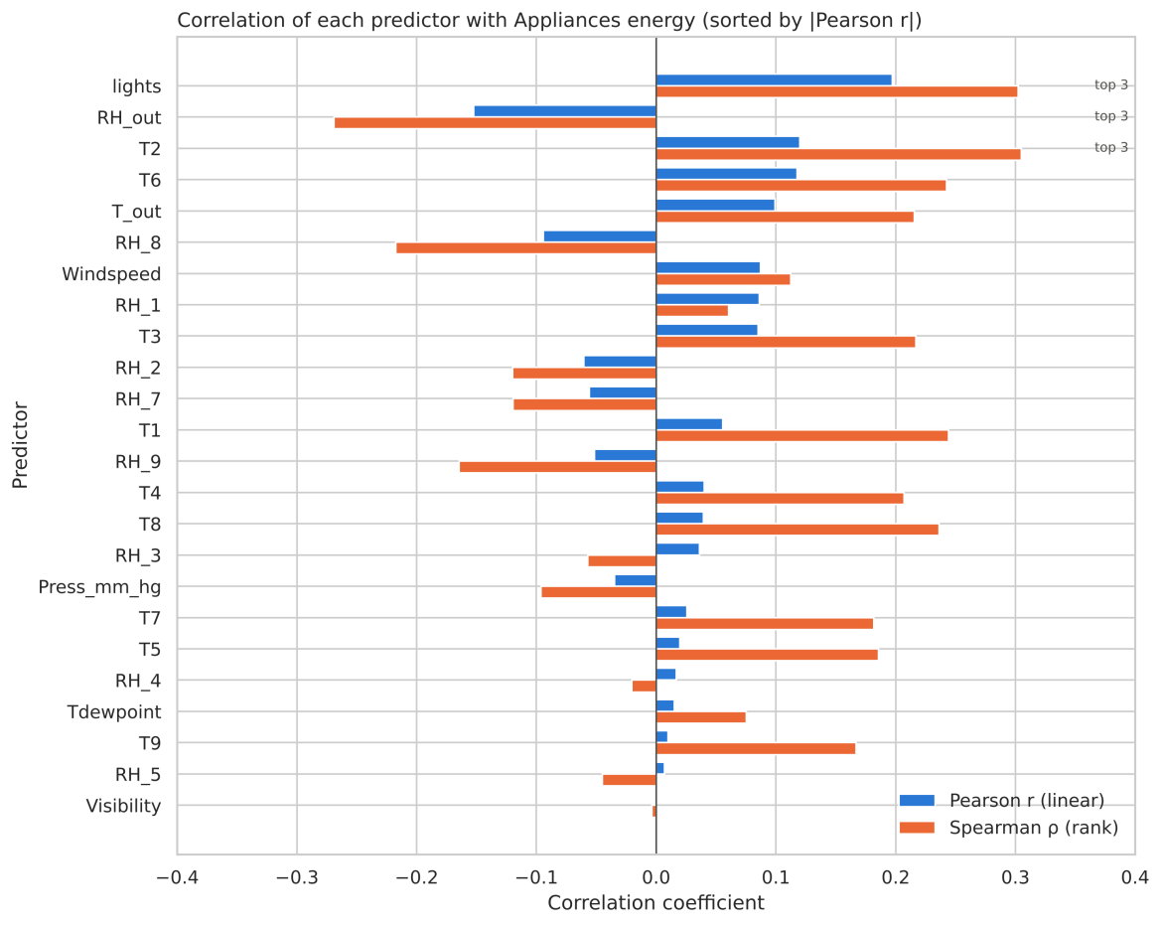
Figure 8: Pearson and Spearman correlation of each predictor with the target.
- Interesting relationships between predictors:
Three groups of predictors move together: indoor temperatures (mean r = 0.83 between rooms), indoor humidities (mean r = 0.68, except the bathroom) and the two outdoor temperatures (T6 vs T_out, r = 0.975). Outdoor humidity falls as temperature rises (RH_out vs T_out, r = −0.57).
- Correlation Heatmap
- Include a correlation matrix heatmap.
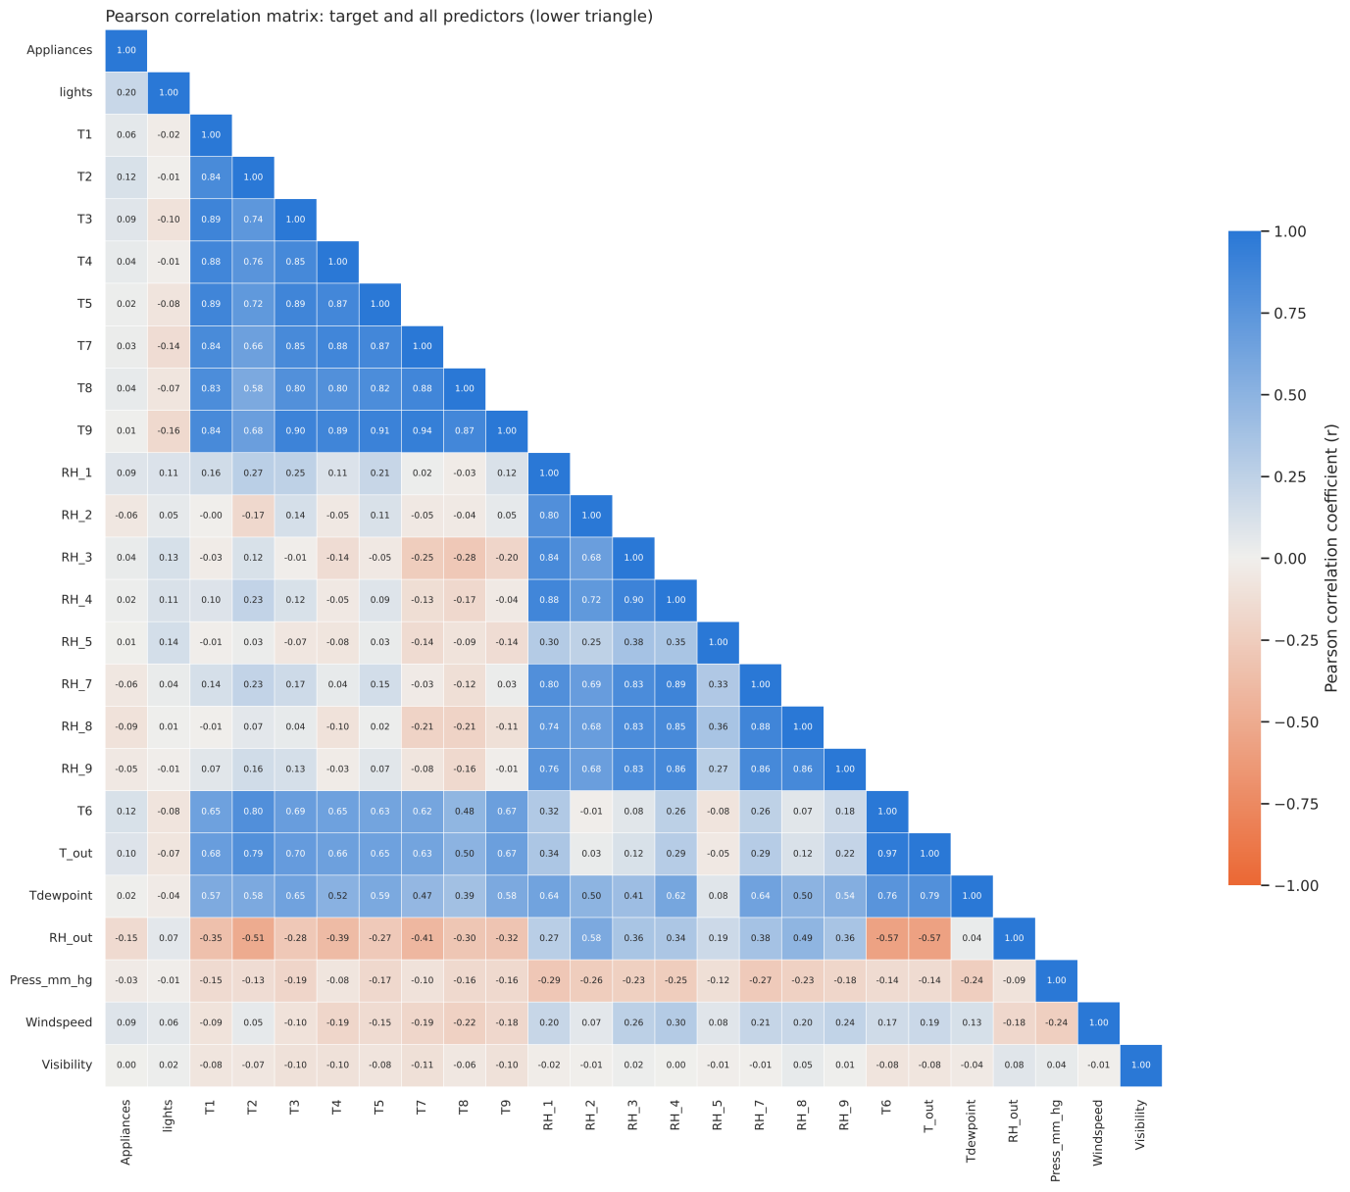
Figure 9: Pearson correlation matrix of the target and all predictors.
- Identify multicollinearity issues (if any).
Severe multicollinearity: 35 predictor pairs have |r| ≥ 0.8 (4 pairs ≥ 0.9; strongest T6–T_out 0.975, T7–T9 0.945), and 14 of the 24 predictors have a variance inflation factor (VIF) above 10. The highest are T_out (135), Tdewpoint (81) and RH_out (43). Tdewpoint is not an independent measurement: dew point is a physical function of temperature and humidity, and T_out and RH_out reproduce it almost exactly (R² ≈ 1.00).
- Predictor Relationships
- Describe important relationships between predictors.
- Discuss patterns (linear, nonlinear, clusters, etc.).
In the pairplot (Figure 10), T6 vs T_out is a tight straight line; T2 rises roughly linearly with outdoor temperature (r = 0.79); RH_out vs T_out is a curved, fan-shaped negative relationship; lights takes only a few discrete values. Seasonal bands are visible in the temperature panels. The three target classes overlap almost completely: the lights are on in 8.9% of Low readings vs 38.7% of High readings, yet 61% of High readings still have the lights off. No single sensor separates the classes, which points to non-linear models and time features.
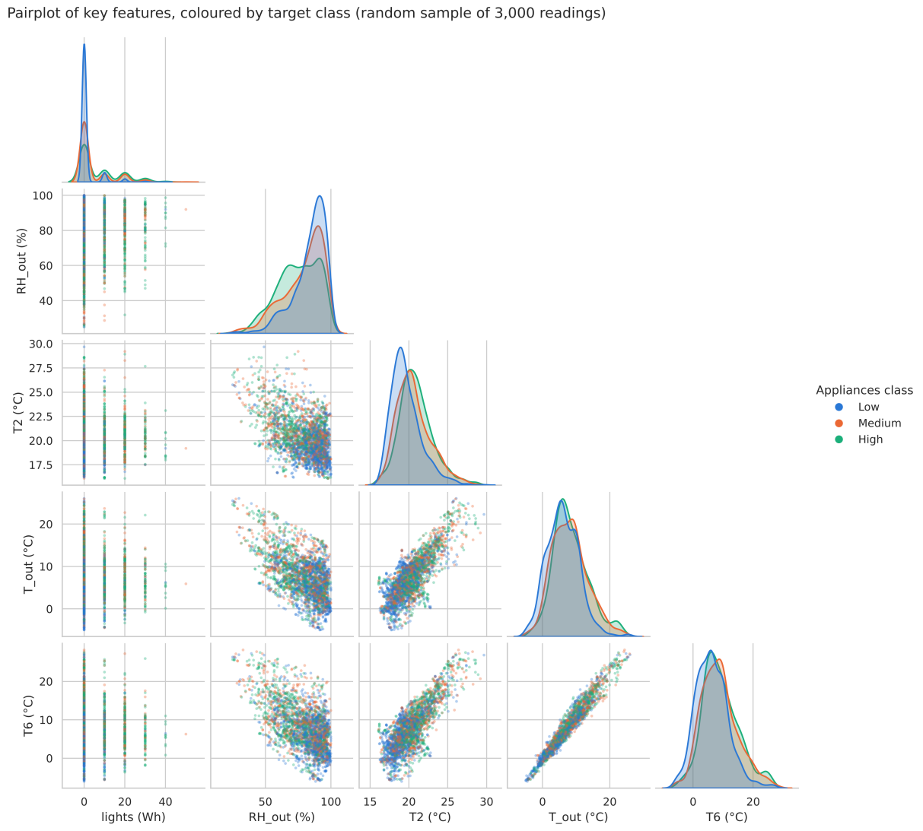
Figure 10: Pairplot of key features coloured by target class (random sample of 3,000 readings).

5. Initial Insights for Modelling (Just write instead of implementing it)
- Which features seem most promising?
  - Hour of day (engineered from date): strongest driver (η = 0.387).
  - lights: strongest sensor and a direct occupancy signal (keeps r = 0.144 within the same hour).
  - Recent consumption: autocorrelation 0.75 at 10 minutes and 0.22 at 24 hours – very useful lag features for forecasting.
  - Activity-related room sensors: T2 (living room), RH_1 (kitchen), T3 (laundry), RH_5 (bathroom); the original study also ranked these highest.
  - Outdoor variables add context but mostly repeat the time-of-day information.
- What preprocessing might be needed?
Feature engineering (hour as sine/cosine, weekend flag, binary 'lights on', lagged consumption), a log or Yeo-Johnson transform for the skewed RH_5, and a time-based train/test split (e.g. train January–April, test May, or TimeSeriesSplit), because neighbouring readings are almost identical and the data drifts with the season.
- Scaling? Yes for scale-sensitive models (logistic regression, SVM, k-NN, neural networks): standardise, fitting the scaler on the training set only, because ranges differ widely (≈755 mm Hg vs 0–14 m/s). Not needed for tree-based models.
- Encoding? All predictors are numeric, so no one-hot encoding is needed. The ordinal target is encoded Low = 0, Medium = 1, High = 2; hour of day is encoded cyclically (sine/cosine).
- Feature selection? Drop Tdewpoint (R² ≈ 1.00 from T_out and RH_out) and one of T6/T_out (r = 0.975), and summarise the indoor temperature and humidity groups (room averages or PCA) to bring VIFs below 10. rv1, rv2 and the faulty RH_6 are already removed.
- What modelling approaches might work well?
  - Tree ensembles (Random Forest, gradient boosting such as XGBoost/LightGBM): capture the non-linear time-of-day effect and interactions, need no scaling and cope with collinear inputs. Gradient boosting was also the best model in the original study.
  - Multinomial or ordinal logistic regression as an interpretable baseline (after scaling and removing collinear features).
  - Sequence models (lag-feature models, LSTM/GRU) if past consumption may be used as input.
  - Evaluate with macro-F1 or balanced accuracy and a confusion matrix, since confusing Low with High is worse than Low with Medium.

6. Engineering Interpretation
- What do the results mean in your discipline?
Correlations in engineering terms. The target covers plug loads only; heating, the hot-water heat pump, ventilation and lighting are metered separately (Candanedo et al., 2017). Consumption is therefore driven by occupant behaviour, not by the thermal physics of the building, which explains the weak sensor correlations (|r| ≤ 0.197). The sensors act as indirect 'soft sensors' of occupancy: lights when people are at home and awake, a warmer living room when it is occupied, kitchen and bathroom humidity from cooking and showers. For an AIoT system, the value of this sensor network lies in detecting occupancy rather than measuring the thermal state of the house.
Unexpected patterns. Temperature barely matters, unlike in most houses, because heating is excluded and the passive-house design buffers indoor temperatures. A published benchmark dataset contains an unreported sensor fault (RH_6). Atmospheric pressure has r = −0.035 yet was the authors' second most important GBM variable: it is almost constant within a day (η with the calendar day = 0.966), so a tree model can use it to recognise which day a reading belongs to – a likely cause of their gap between training (R² = 0.97) and testing (R² = 0.57). Weekends look like weekdays (mean 100.6 vs 96.6 Wh), consistent with one adult working from home.
Physical and process relationships. A daily occupancy cycle (≈300 W base load at night from the fridge and standby devices; evening cooking peak at 17:00–20:00); peak loads dominate the energy (the High class is 31.5% of readings but 62.1% of appliance energy; the top 10% of readings use 37.1%), which is what matters for demand response; heat transfer in an airtight, insulated building (indoor temperatures move together and warm with the season); and psychrometrics (relative humidity falls as air warms, and dew point is determined by temperature and humidity).
Missing features. Occupancy (people count, motion/door sensors or CO₂), appliance-level sub-metering (smart plugs on the oven, washing machine, dishwasher), calendar information (holidays, home-office days), on-site solar irradiance, heating and hot-water state, and lagged consumption.
- What type of model might suit this dataset?
A non-linear tree ensemble (gradient boosting or Random Forest) with engineered time and lag features, trained and validated with a chronological split. It matches the evidence: weak and non-linear sensor relationships, a dominant daily cycle, strong autocorrelation, collinear inputs and features on very different scales. A multinomial logistic regression is useful as a baseline to show how much the non-linear model adds.

7. Challenges Encountered
The main difficulties and how I resolved them:
- A 'clean' dataset that was not clean: no missing values or duplicate rows, but RH_6 was faulty. It was only found by comparing it with an independent sensor and checking for readings stuck at sensor limits; deciding between interpolation and removal also required evidence (the drift affects all readings from March).
- Outlier rules that do not fit the data: IQR flagged 22.7% of lights, 12.8% of Visibility and 10.8% of the target. Each variable had to be judged by its physical meaning; removing them would have deleted real behaviour.
- Meaningless duplicated columns: rv1 and rv2 look like normal features and had to be identified before removal.
- Discretising a skewed, stepped target: equal-width bins were unusable and the 10 Wh steps constrained the equal-frequency boundaries, so I accepted three classes with a wide High class.
- Weak and confounded correlations: all below 0.2, with Pearson and Spearman disagreeing; extra analysis (correlation ratio, within-hour correlation) was needed to show that time of day is the real driver.
- Summary statistics hiding structure: multimodal temperatures with low skewness and the Visibility spike were only visible in the plots.
- Environment reproducibility: installing the requirements on Python 3.15 failed because PyYAML (a Jupyter dependency) had no pre-built package for that version on Windows; I switched to Python 3.13, kept requirements.txt minimal and computed VIF and the bimodality coefficient with NumPy/pandas to avoid extra libraries.

8. Reflection Questions
- How might poor data quality affect model reliability?
  - Silent sensor faults: a model trained with RH_6 would learn its drift (which follows the season) as a real signal and degrade silently after the sensor is repaired or replaced. Even benchmark data needs validation, and a deployed AIoT system needs automatic sensor-health checks (range, stuck-value and cross-sensor checks).
  - Artificial smoothness and limited coverage: weather data interpolated from hourly values is smoother than real-time inputs, and only January–May is covered, so summer behaviour is unknown.
  - Leakage and over-optimistic evaluation: consecutive readings are highly similar (autocorrelation 0.75) and pressure identifies the day, so a random split inflates scores; the original study's train/test gap (R² 0.97 vs 0.57) shows the risk.
  - Label quality: classes depend on the chosen boundaries (80 Wh is Medium, 90 Wh is High), so errors near boundaries should not be over-interpreted.
- What ethical or bias issues might exist in this dataset?
  - Sampling bias: one newly built passive house in Belgium with one family (two adults, two teenagers, one adult working from home). A model would not generalise to other households (e.g. shift workers, older people at home all day), building types or climates, and could systematically mispredict for them.
  - Privacy: 10-minute energy and lighting data reveal when people wake, cook, shower, sleep and leave home. This requires informed consent, data minimisation (e.g. hourly aggregation), secure storage and GDPR compliance.
  - Fairness and transparency: if predictions drive tariffs, demand-response requests or advice, households unlike the training household would be served less accurately; occupants should know what is inferred about them, and automated decisions should be reviewable by a person.

9. Next Steps
With more time I would:
- Engineer time features (cyclic hour, weekend flag) and lag/rolling features, and measure how much each adds.
- Train and compare a logistic regression baseline, Random Forest and gradient boosting with chronological cross-validation (TimeSeriesSplit), using macro-F1 and confusion matrices.
- Reduce multicollinearity (room averages or PCA) and check the effect on model stability and VIF.
- Test whether pressure and other slowly varying weather variables cause overfitting by dropping them and comparing test scores.
- Try alternative class definitions (e.g. splitting the wide High class) and regression on log(Appliances) for comparison.
- Use explainability methods (feature importance, SHAP) to check that the model relies on plausible drivers such as time of day and occupancy.

10. GenAI Declaration
The required GenAI Use Declaration is given at the beginning of this report (page 2). Evidence of the GenAI use is provided in Appendix A.

References
Candanedo, L. (2017). Appliances Energy Prediction [Dataset]. UCI Machine Learning Repository. https://doi.org/10.24432/C5VC8G
Candanedo, L. M., Feldheim, V., & Deramaix, D. (2017). Data driven prediction models of energy use of appliances in a low-energy house. Energy and Buildings, 140, 81–97. https://doi.org/10.1016/j.enbuild.2017.01.083

Appendix A – Evidence of Generative AI use
Dataset suggestion:
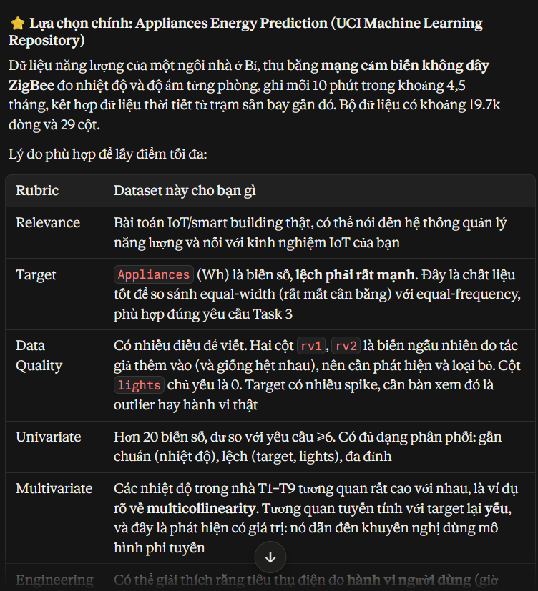
Debugging my Python environment.:


